Ask Your Vet: Health and Sports

Sanath. M

*Department of Computer Science, Presidency University*

Bengaluru, India sannath391@[gmail.com](http://gmail..com)

Himansu Sekhar Rout

*Assistant Professor,*

*Department of Computer Science, Presidency University*

Bengaluru, India

himanshu.rout@presidencyuniversity.in

Rajashree. S

*Department of Computer Science, Presidency University*

Bengaluru, India rajashreesraji2004@gmail.com

Niha Naaz

*Department of Computer Science, Presidency University*

Bengaluru, India nihanaaz018@gmail.com

***Abstract: When it comes to the care and well-being of our animals, veterinary advice and guidance is often at a premium, and yet, rural or remote communities, and those in developing countries, can face significant challenges in accessing quality veterinary care. This is what the veterinary consultation platform Ask Your Vet is aiming to address, which serves to bridge the gap between pet owners, animal caregivers, and livestock managers on the one hand, and veterinary professionals who can give advice that’s tailored to each animal's needs. By using AI-powered advice to replace, and not necessarily replace. In-person consultations, Ask Your Vet offers accessible expert guidance, is able to pick up on signs of problems early on, and delivers educational resources. This paper examines the fundamental operations of the platform, goes over the process of getting started, the ethics, technical know-how, and real-world scenarios that the platform plays in the field, with a focus on universality, fairness, and effectiveness in bringing animal healthcare to people who need it.***

Index Terms: animal well-being, looking after pets, vet check-ups, staying healthy, prevention tips, feeding right, being a good owner.

I. INTRODUCTION

Animals are very important to human societies because they either coexist in the domestic environments, provide labor or support production in the agricultural fields. In case of health deficit in these organisms, the consequences spread out to their caretakers, affecting affective and physiological conditions. However, a significant number of animal owners are faced with the challenge of accessing high-quality veterinary advice due to geographical location, limited finances, or lack of knowledge on the first action. Others are also faced with many maladies that are relapsing, or have issues with nutritional management, or aberrant behaviors that are difficult to solve.

Ask Your Vet program offers credible help from specialists and is supplemented by information that is context-specific in relation to pet care. As a replacement for the traditional in-person veterinary visits, it provides value-added services, including emergency consultations, prophylaxis, and daily wellness guidelines that prove beneficial to the welfare of animals.

Veterinary counsel is not only detecting disease and prescribing pharmacologic therapy, but also includes educational aspects to owners, behavioral counselling, dietary maximization, and emotional counselling. Ask Your Vet provides caretakers with clear instructions, which lead to better health results, lower anxiety, and enhanced human-animal relationships.

This discussion looks at the role of veterinary guidance, the structure of its organization, and the effectiveness of complementary strategies in the face of the related challenges and provides recommendations to achieve fair, viable, and holistic care.

II. WHAT IT’S FOR AND HOW FAR IT GOES

ASK YOUR VET

1. Understanding builds strength

One fact can be much more than medicine in times of taking care of a pet. Our goal at Ask Your Vet? To simplify difficult vet science in a way that you could understand immediately - no misunderstanding, but simply put. Noticing minor alterations before they get severe, making your meal, and adjusting it to the needs of your animal - all crisis averting, pain-soothing. Such information has no waiting time; it works.

1. Tailored support that fits different life situations

One of a kind, and as such, how they are treated should be the way they should be treated. Ask your vet questions that match the specific type, breed, location where they stay, their age, their medical history, as well as their daily routine. By doing it so at least you do not merely have help thrown together, but what each animal actually needs.

1. Connecting cities with countryside areas

Cities also have locals who take care of pets and do not have enough time, or they lose their way to locate veterinary care. In rural areas, it is a stretch, and not that many professionals are available, and it is difficult to get immediate attention. Due to Ask Your Vet, pet watchers all over the world have convenient access to pros - regardless of their whereabouts - and access good knowledge when required.

III. HOW VET VISITS WORK

A. First Look:

Understanding the Animal’s Health Context

The biggest necessity in giving guidance is facts. Ask Your Vet requests them to submit complete check-in reports to ensure that pet owners communicate what they require; by filling out full check-in sheets that must include: Medical history and any past medical conditions and how they were managed; current medical conditions, including any new symptoms or behavioral changes, eating habits in conjunction with meal times and activity levels; environment with climate, living conditions and exposure to hazards; and whether they are up to date on their vaccinations with countermeasures to pests.

A pet helper spots their Lab guzzling way too much water and getting thinner. Their Lab is gulping down excessive water and is losing weight, which prompts a pet helper to notice. The program takes them through the process of how to identify potential hints of diabetes, administer diagnostic tests, and provide dietary modifications - all with the stress that they should visit the doctor to do the requisite blood tests.

B. Stopping problems before they start

Premature action keeps your pet feeling good by catching tiny problems before they grow.1 Talk to your vet regarding the progression of the shots, the methods to prevent the onslaught of pests like fleas or worms, how often to give baths and brush, methods on physical activity, according to the size and life stage, and also the fun arrangements that help to keep things lively and at ease.

Stress causes cats' bladder problems or a lack of water. Ask Your Vet demonstrates to pet owners how to keep cats hydrated, such as playing with them to reduce anxiety, or by making litter boxes clean.

C. Handling What You Eat:

Diet often gets ignored when people look after pets. With help from your vet, you can build meal plans that fit exactly what an animal requires - right amounts of protein, healthy fats, essential vitamins, along with needed minerals; eating routines adjusted for health issues such as overweight problems, allergic reactions, or failing kidneys; food rules based on life stage, whether young, grown, or older pets; common household items humans eat that won’t hurt animals if added carefully to their dishes

A household managing their chubby Bulldog gets a seven-day food schedule showing serving amounts, daily energy goals, besides approved snacks. Regular weight utilization checks keep track of the progress without necessarily suffering a deplorable diet.

D. Mental well-being linked to actions:

Animals feel stressed, anxious, or down - just like people do. When their daily life shifts, they go through something scary, or get cut off from others, it can lead to odd actions. Ask Your Vet gives you tools: check-ins that dig into what’s really going on; ways to calm nerves using breathing tricks and setting a steady schedule; tips for helping shy pets warm up to creatures or folks around them; plans to handle outbursts, repetitive habits, and intense fears.

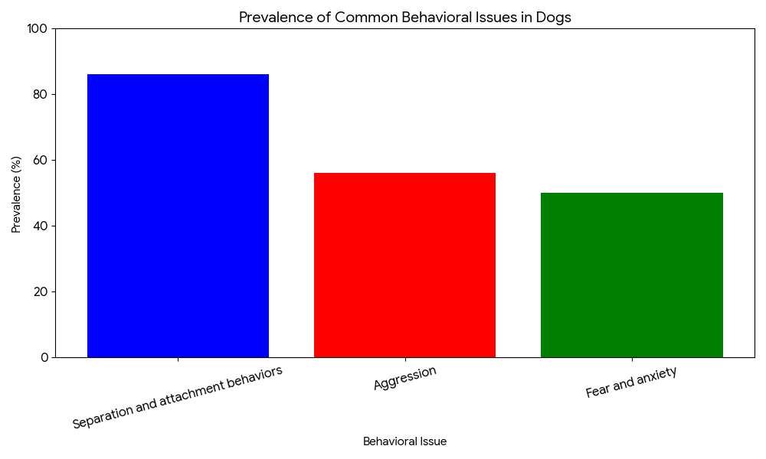

*Figure 1.0 shows how split-up actions and clingy habits pop up way more often compared to hostile moves, scared reactions, or nervous patterns in the tested dogs*

A scared pup from a rough past acts out due to fear. To help, Ask Your Vet walks the owner step by step - using calm exposure tasks, treats for good behavior, or changes around the home - to slowly grow confidence.

*Figure 1.0 graph demonstrates that separation and attachment behaviors are significantly more prevalent than aggression, fear, and anxiety among the sampled dogs*

Example: A rescue dog previously mistreated exhibits fear-based aggression. Ask Your Vet guides the caregiver through gradual desensitization exercises, reward-based training, and environmental adjustments to build trust.

IV. STORIES FROM ACTUAL USE -

USER SCENARIOS

A. Example One: Long-term Joint Pain in an Older Dog

Background:

The case of a 12-year-old Golden Retriever presents a joint pain issue that makes the movement difficult. Ensuring stiffness presents itself every morning with a slowing of every movement it makes. Difficulty in getting up after a sleep occurs frequently today compared to the past.

Ask Your Vet assists the people caring about their pets to identify the early signs of joint problems and next directs them to start with easy exercises; it also provides advice on the planning of beneficial supplements such as glucosamine combined with chondroitin. The procedure is based on the control of pain by means of the timetable of medicine use kept by the vet, which is designed according to the needs of every pet. The dog begins to walk once again, and hence it might have more walk,s and its general health improves without any operation.

B. Example 2: Feeding Problems in Cats

Background:

A multi-cat household most frequently has to contend with constant illness, such as lack of energy, shedding of fur, or gastrointestinal issues.

Ask Your Vet examines your pet food, finds a problem - dry food without moisture could be the cause of pee problems. It recommends adding canned food that will assist in correcting this issue, rather than kibble only. There is also a way to sustain water intake throughout the day. The deviant misunderstandings about switching chow are also cleared up.

The cats are more energetic as their fur is in better condition, and they have fewer health problems.

C. Example 3: Nervous Habits in Shelter Pets

Background:

Regarding a shelter filled with rescued pets, the people who work there are faced with hostility from their charges. However, the organisation "Ask Your Vet" takes a very different approach, and gets down to business by laying out a detailed routine for each pet's life, much like meal times, playtime, and fun activities, and doing so with the advice of experts.

They teach the staff more about gentle and soothing ways of handling animals, putting them through hands-on training to become experts in the area. The results show that the animals relax, and so do the workers. Even more people want to adopt these well-cared-for pets, and injuries in the shelter are fewer.

V. MORAL RULES AND SAFETY PROTOCOLS

A. Making sure recommendations come from solid proof

All the tips of Ask Your Vet are based on researched studies, as well as experience. Alterations are frequent with close observation, thus ensuring that everything remains in check with the current state of affairs as far as vets treating animals are concerned. We do not use intuition or tradition in making decisions. Instead, we rely on experienced experts through recent journal and practical field test outcomes, as well as those findings provided by the vet organizations and guesstwork, ensuring that each recommendation works, pets are safe, and the techniques are current. That way lets you be sure that what you end up with is not what - it is good information that you can rely on (fig:1.1).

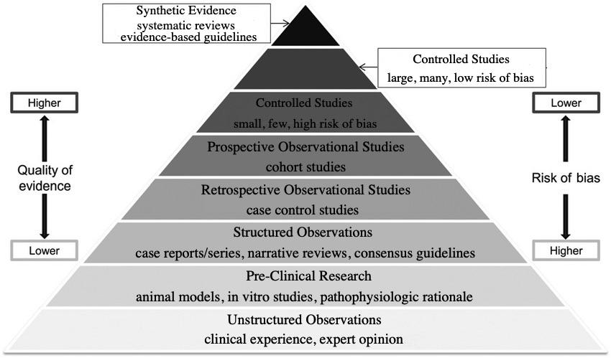

*In Picture 1.1, the evidence is weighted at the bottom - the evidence that is most doubted and can be readily discovered is the least reliable, whereas the evidence that is the most reliable is that which is furthest down and more difficult to locate.*

B. Helping people understand before they agree

Individuals are supposed to understand that there are some risks associated with some therapies, but they should visit a specialist in case the symptoms are persistent or become severe.

C. Keeping things private + not sharing secrets

User data - such as health background and notes of visit is encrypted when stored. Access to private details? Did just accept verified members of staff. Besides, individuals assist the patients in learning how to adhere to confidentiality policies.

VI. NEW TECH STUFF

The Ask Your Vet site runs on up-to-date cloud tech, keeping vet advice sessions steady, expandable, and protected. Its layout focuses on easy use without sacrificing strong behind-the-scenes performance.

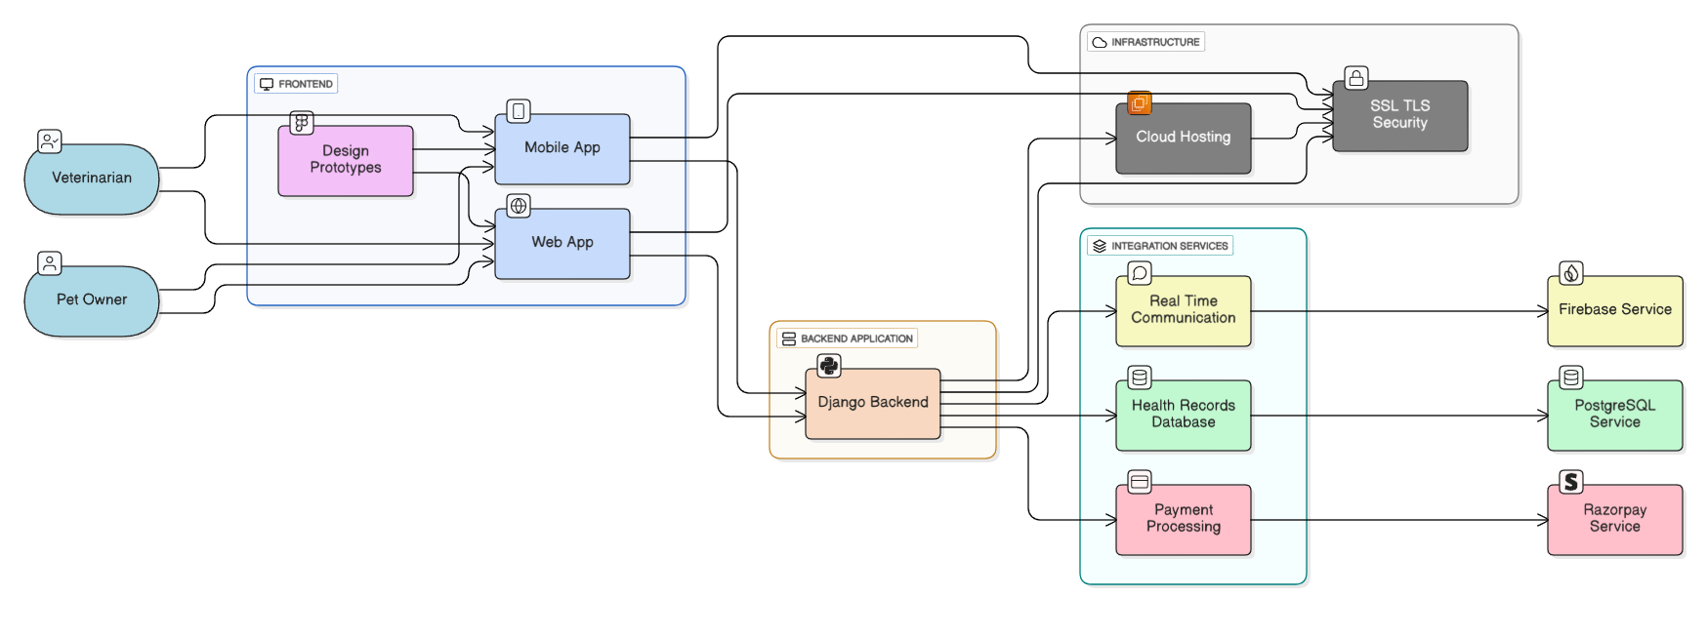  
*Fig. 1.2: Detailed design of the Ask Your Vet application demonstrates data flows within the system between screens on devices and server functions, which happen before sending data to online storage, as well as with external applications.*

A. Structure of the front-end part

The system allows an easy interaction between the various points of access as well as adjust to the needs of the customers: The application targeting only veterinary professionals and pet owners would allow customers to make their appointments quickly and everywhere; the design of the application includes a touch interface to allow easy navigation; the application would allow users to take pictures in the app to record the clinical signs; the notification functions will provide the user with all the available information and updates about an upcoming arrangement regardless of whether he has an active internet connection; even without the active internet connection, the user will have an opportunity to interact with the system.

A web based interface that can be accessed using standard browsers provides a desktop like experience without installing any software; the interface has advanced functionalities to support any veterinary examinations enabling practitioners to make thorough assessments; medical records can be handled easily with a well managed interface; practice managers can have custom web based dashboards that enables them to review their appointments, personnel and bills in one place; the interface can be viewable in various screens, and users can easily switch between tasks without losing their context.

Design prototypes considered both the real people and the external users, and thus this allowed user-centred experience and thus were intuitive to both animal caregivers and veterinarians; such configuration is based on well-defined accessibility principles, responsive support with respect to different screen sizes, hierarchical visual structure, and dynamic adaptation of the layout when needed, thus, creating a natural workflow which does not require so much steps to conduct an examination without focusing on the detail orientation.

B. Server setup along with the API system

The Django back-end manages all central processes, and it should provide powerful performance with scalability.

* **RESTful API Architecture**: a group of endpoints ensures the smooth flow of information between the frontend application and the back-end service; the set of endpoints is based on the principles of REST, utilizing supporting HTTP status codes, facilitating request/response schemas, versioning, intending backward compatibility, and massive documentation to promote third-party integration.
* **Authentication and Authorization Systems**: multi-layer security architecture means that the role-based access control (RBAC) system will be used in the system to provide authentication and access to users (veterinarians and pet owners) and administrative people; it is planned to have: secure token-based authentication processing and support OAuth options of social logins, use of two factors-authentication in case of sensitive operations as well as automated session management including configurable time limits.
* **Session Management and Request Handling**: Optimized request processing system designed to handle concurrent user sessions efficiently. The system implements connection pooling, request queuing mechanisms, load balancing across multiple server instances, and real-time performance monitoring with automatic scaling capabilities.
* **External Service Integration**: the strong connection with third-party services will be provided through an impressive integration layer, which covers payment gateways, notification systems, cloud storage providers, and veterinary laboratory networks where the test results are ingested.

### C. Cloud Infrastructure and Security Framework

The site will be implemented based on enterprise-level cloud infrastructure to ensure maximum availability, security, and scalability:

* **Data Encryption and Transmission Security**: The protocols of Drupal Integrity and Privacy SSL /TLS, the 1.3 version uses encrypted data between all client-server activity; other measures are provided to assure end-to-end encryption of sensitive health records, secure key handling, and frequent penetration and security audits, and regular security audits and penetration testing.
* **Scalable Hosting Solutions**: Auto-scaling cloud service supports variable user loads as few as a single consultation up to thousands of users; the system can be horizontally scaled and configured to load-balance, implement a content delivery network to enhance performance globally, geographic redundancy to help in case of disasters, etc.
* **Data Protection and Compliance**: there are data protection and backup plans, disaster-recovery plans, such as daily automatic backup operations, point-in-time backups, and compliance with veterinary data-protection regulations such as HIPAA-equivalent regulations of animal health records.
* **Performance Monitoring**: real-time system monitoring and alert systems identify and rectify problems beforehand to have minimal service interruptions

### D. Integrated Services and External APIs

The platform integrates third-party services specialised in an effort to improve functionality and user experience:

* **Real-Time Communication Services**: Firebase-based infrastructure will offer instant messaging between the veterinarians and the pet owners, high definition video calls with screen-sharing, file sharing of medical documents and images and also allow consultations to be conducted in groups to engage more specialists in complicated cases.
* **Health Records Database Management**: PostgreSQL-based database provides secure storage and efficient access to all-inclusive animal health information; it has encrypted storage, automatic backup procedures, quick querying of extensive datasets and easy connection to practice-management systems.
* **Payment Processing Integration**: a well-protected Razorpay gateway application is integrated to provide various forms of payments, such as credit/debit cards, digital payment wallets, and bank transfers; the platform will ensure high effectiveness in the context of PCI DSS, and the automatic generation of invoices, subscription plans, and care continuation, and keep fee-related settings transparent.
* **Notification and Alert System**: Firebase Cloud Messaging supports a fully developed notification system to send appointment alerts, medication alerts, a follow-up notification, and an emergency notification channel, and has full customization of preferences and channels of delivery.

### E. System Performance and Reliability

This highly designed architecture would make sure that Ask Your Vet could effectively serve multiple users simultaneously without damaging the integrity of the data and providing both invigoratingly responsive experiences across all points of interaction. It has a modular design whereby separate options of many components are enabled to scale up and down depending on the changes in demand, thus maximising the use of resources and economic costs.

The core service response time of less than one second on common queries, a 99.9% uptime guarantee, and the automatic activation of failover capability in the event of failures are all achieved. The updates are installed automatically without interruption of the user's activity. The flexible architecture also ensures that new features or integrations can be added to the architecture without affecting the stability and interoperability between the old parts.

## A. AI and Predictive Analytics

In the future, the system utilizes intelligent technology to identify early warning signals, and thus allows the team to find solutions to the issues before they worsen, which will prevent the development of problems.

## B. Wearable Technology for Animals

This technology is designed to track animals inside their stables or pastures to monitor their health conditions and whereabouts.

Combining smart collars and health trackers, the solution will provide stable updates and insights about movement, resting habits, and physiological changes, which would allow the caregivers with the ability to respond timely manner in case any deviations are detected.

## C. Teleconsultation Options

The system enables real-time video consultations where animal physicians are not easily accessible in the areas of the country, so the animal physicians can consult caretakers in real-time on the steps to follow during the procedure, which eliminates the necessity of a physical visit until the need arises.

# VII. USER ENGAGEMENT AND COMMUNITY SUPPORT

Ask Your Vet is not simply a technological tool; it aims to create a sense of community.:

* The owners interact with each other using online seminars, discussion forums, and live expert discussions. Regardless of the level of experience, the joint search for pet care is an advantage to all members, as demonstrated by the use of forums with veterinary experts giving trustworthy knowledge and support to fellow members in managing chronic illnesses or the intricacies of training young dogs.
* On-demand live question-answer meetings and webinars, organized by experts who have an in-depth understanding of dermatology, nutrition, and behavior, welcome real-time engagement, whereby audience members can inquire about dermatology, nutrition, and behavior questions in real-time. These thematic concerns change throughout the sessions, between a preventive approach and highly effective therapeutic treatments, combining educational materials, along with personal dialogues, thus providing highly personalized answers, which meet the demands of each specific pet. The facilitators not only lecture but also listen and dynamically respond, thereby creating a collaborative situation.
* The observed and witnessed results in practice are directly evidenced by specific health improvement and daily life change outcomes; these stories produce credibility and motivation in owners and carers who go through the difficult conditions.

This comprehensive toolkit transforms Ask Your Vet into not just another service but into a strong support in the form of a well-built network of pet health, which indicates that the best health of pets is determined by collaborative work between veterinarians and committed pet owners of pets with mutual responsibility.

*Implementation of the "Ask Your Vet" Mobile Application*

The proposed strategy is to use the Ask Your Veteran Mobile Application.

The Ask Your Vet application helps pet owners get reliable and convenient veterinary advice right away on their mobile phones, thus creating a simple connection with the veterinarians. The system to maintain the best performance will use three technical parts: Flutter to provide the mobile interface, Django will handle server-side operations, and React.js will handle web interfaces between veterinarians and administrators.

The application is accessible to all owners of pets, who are allowed to register it, upload their images to receive diagnostic help, ask a question, and get a quick reply. Developed on Flutter, the mobile application will run on Android and iOS with zero latency and defects. Clients get all-time updates about veterinary responses or appointment findings.

To ensure data confidentiality and integrity, the backend is based on the Django REST Framework, which contains user authentication, consultation records, known as the administration, arranges veterinary appointments, and provides safe RESTful APIs. This modular structure will allow the web and mobile clients to access the requisite information independently without affecting consistency and security.

A dynamic dashboard developed using React makes the work of a veterinarian easier, as it enables them to control consultations and visit planning. Because it’s made using JS tools, swapping parts works without slowing things down. Each section runs separately, so updating patient info or responses feels fast and simple during busy clinic hours.

*The important lessons of development.*

Points: In the process of building the System, Scratch by Scratch.

The key lesson that we had was a high divide between front-end and back-end logic. With the help of RESTful APIs, it becomes possible to provide ongoing updates, as well as scalability. We used JSON Web Tokens to perform token-based authentication, and all the communications were done over HTTPS, which provides the security of user health information. Image uploading and notification asynchronous was the key technical issue; this required a strict analysis of the state management of Flutter and React.

Our secret plan was to get a perfect experience on a wide range of devices: the cross-platform nature of Flutter makes no difference in running and managing changes to respond quickly to changes in the overall codebase, thus providing a consistent UX/UI on all interfaces. It also saves us money on laboratory costs and allows us to increase our user base at the least maintenance cost.

*User Interface Design*

The design is user-friendly and even beautiful and a user can easily navigate when asking questions or booking an appointment. The veterinary portal also utilizes the same authentication token, and pending cases, profile information, and scheduling are presented with a unified aesthetic that is consistent with the brand story of the app.

*Prerogative Pet Owners and Optimizing Vet Operations.*

The great benefits to pet owners are the assistance given instantly to train their pets and to give general health check-ups. Owners will be able to ask questions, share images and be guided with the non-urgency of face-to-face care. In addition, the app sends notifications on vaccinations, veterinary visits, and training. Therefore, owners tend to be more organized, healthier, and efficient, and will not need to worry about missing certain tasks when there are a lot of things to do.

The app provides an advantage to veterinarians because it helps them to organize consultations and schedules in a single web interface. They are able to answer questions when it suits them, they can control their schedules, and computerise patient records. This makes it easier to share information between veterinarians with each other and makes future treatment decisions. The instrument enhances telemedicine and preemptive healthcare, limiting the workload of administration.

Among the above advantages, the application has the capacity to develop an ecosystem that promotes good behavior in pet care among owners and supports veterinarians to handle their professionalism and patients.

VIII. CONCLUSION

Ask Your Vet is a strong platform through which animal health provision is advanced in the world. Our approach, through creating a crossing between professional advice, personalized care, guardianship, and community-related programs, will enable the caregivers to provide holistic, loving, and evidence-based treatment that matches the worth and needs of the animals. Ask Your Vet will ensure that it provides the best care to dogs, cats, and all other animals, including routine checkups and treatment procedures. We are loving and respectful to every animal.

We attempt to change the perceptions of the population regarding pet health. It is our goal to increase the effectiveness of your visit to the veterinarian for the well-being of your pet!

References

*[1] American Veterinary Medical Association, Veterinary Telehealth: The Essentials. Retrieved from:* [*www.avma.org/ resources-tools/animal-health-and-welfare/telehealth-telemedicine-veterinary-practice/veterinary-telewell-being fundamentals*](http://www.avma.org/)

*[2] B. A. Albadrani, M. A. Abdel-Raheem, and M. I. Al-Farwachi, Veterinary telemedicine: A for animal Open Veterinary Journal, 14(4), Apr. 2024. Retrieved from:* [*https://www.ncbi.nlm.nih.gov/pmc/articles/PMC11128645/*](https://www.ncbi.nlm.nih.gov/pmc/articles/PMC11128645/)

*[3] L. M. Teller, Looking at the opportunities and difficulties with veterinary telemedicine, Vet. Rec., Sep. 2022. Retrieved from:Explori,*[*https://www.researchgate.net/publication/363420225 ng: the opportunities and obstacles offered by veterinary telemedicine*](https://www.researchgate.net/publication/363420225)

*[4] D. Levine, A. P. Markley, D. J. Marcellin-Little, and H. Reesink, Editorial: Sports medicine and physical Frontiers in Veterinary Science, Volume III, Rehabilitation, 12, 1551208, Feb.2025.Retrievedfrom:*[*https://pmc.ncbi.nlm.nih.gov/articles/PMC11880228/*](https://pmc.ncbi.nlm.nih.gov/articles/PMC11880228/)

*[5] T. Atalaia, J. Prazeres, J. Abrantes, and H. M. Clayton: Equine Rehabilitation: Survey of Studies, May 2021 11(6), 1508.Retrieved at* [*https://www.mdpi.com/2076-2615/11/6/1508*](https://www.mdpi.com/2076-2615/11/6/1508)

*[6] Grandjean, Grandjean, and Ferrante, Good Nutrition for Athletic Performance, Emphasis Journal of Nutrition, on Fat Use in Horses and Dogs, Jan. 1995, 124(12), pp. 2745S–2753S.Gotfrom:*[*https://pubmed.ncbi.nlm.nih.gov/7996286/*](https://pubmed.ncbi.nlm.nih.gov/7996286/)

*[7] T. L. Richards, A. Rankovic, J. P. Cant, A. K. Shoveller, J. L. Adolphe, D. Ramdath, and A. Verbrugghe, How Total Store-Bought Extruded Dog's starch and resistant starch Foods Affect Siberian Huskies' Stomach Emptying, animals, 11(10), 2928, Oct. 2021. Retrieved from:* [*https://www.mdpi.com/2076-2615/11/10/2928*](https://www.mdpi.com/2076-2615/11/10/2928)

*[8] S. Burron, T. Richards, K. Patterson, C. Grant, N. Akhtar, L. Trevizan, W. Pearson, and A. K. Shoveller, Is It Safe to include Camelina Oil in the diets of fit adults. Dog?” Animals, 11(9), 2603, Jun. 2021. Recovered from:* [*https://www.mdpi.com/2076-2615/11/9/2603*](https://www.mdpi.com/2076-2615/11/9/2603)

*[9] J. Atwal, J. Stockman, M. Gilham, D. Allaway, H. Renfrew, A. M. Bakke and P. Watson, No Seen Bad Health Signs Seen in Adult Beagle Dogs Given a High-Calcium Diet, 11(6), p. 40 Weeks High- Calcium Diet, 1799, June 2021. Retrieved from* [*https://pmc.ncbi.nlm.nih.gov/articles/PMC8234157/*](https://pmc.ncbi.nlm.nih.gov/articles/PMC8234157/)

*[10] C. Delsante, V. C. O’Leary, G. Biagi, M. Grandi, and F. Marelli, An Online Study of How Dog and Cat Owners Store and Feed Pet Food, Animals, 11(5), p. May 2021; 1478. Retrieved from:https://www.mdpi.com/2076-2615/11/5/1478*

**Sanath. M** **(Student Member, IEEE)** was born in 2003 in Bengaluru, India. Currently, he is studying a Bachelor of Technology in data science from the Presidency University, Bengaluru, India, with a major field of data science and a minor in healthcare and digital systems.

He already developed a few systems in data Analytics, artificial intelligence, and Cloud-based applications during his case study work. Recentl,y he and his team developed a veterinary telemedicine platform, Ask Your Vet: Health and Sports, a digital platform that facilitates digital data record-keeping of the animal’s treatment history, teleconference between farmers/owners and veterinarians and a new digital way to receive veterinary support for the animals for which I took the responsibility of the development of the digital health record acquisition. The areas of research interests comprise telemedicine, digital platforms for healthcare, and the development of more efficient decision systems based on data and AI for social welfare.

Mr. Sanath is also a student member of the IEEE Computer Society. He actively participates in innovation programs and university-level projects that are related to technology for public utility purposes and sustainability.  


**Rajashree S (Student Member in IEEE)** was born in Chikkaballapur, India, in 2004. She is a student at Presidency University, Bengaluru, India, pursuing her B.Tech in Computer Science and engineering specialization in Data Science.

Her work includes hands-on experience in areas like machine learning, digging into datasets, along building web apps. In the recent past, she designed a platform called Ask Your Vet: Health and Sports, a web-based tool that allows pet owners to reach professionals in the veterinary field remotely, maintain electronic health records of their animals, and get advice on preventive animal care outside of the clinical encounter. She has shared news through Facebook on the most prominent mobile health, digital care, artificial intelligence, and data science developments through professionally edited channels.

One of the members of the IEEE Computer Society is Rajashree, who is currently a student and has taken part in numerous campus-based technological programs aimed at solving hands-on problems.



**Niha Naaz (Student Member in IEEE)** was born in Mandya, India, in 2004. She is a student at Presidency University, Bengaluru, India, pursuing her B.Tech in Computer Science and engineering specialization in Data Science.

Her work includes hands-on experience in areas like Artificial Intelligence, data processing, and web-based platforms. Her latest research focuses on creating intelligent applications for health and digital services. and B.Tech in her research are Machine Learning, Data Science applications, Health care technology, and AI for social good.

Ms. Niha is a Student Member of IEEE Computer Society, and has been involved in academic projects, technical events, and innovation programs working with the application of technology for community social and education development.